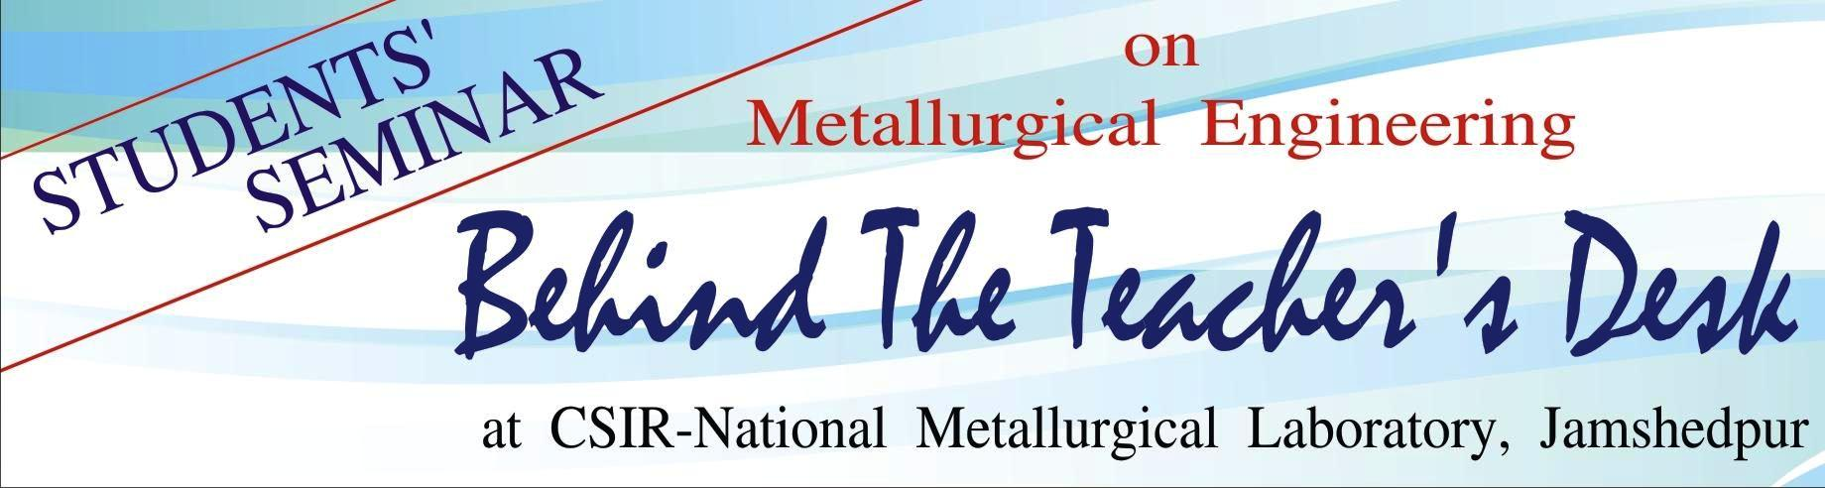
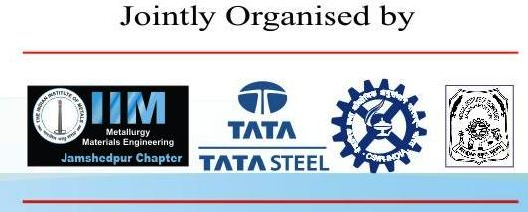
During 5-6 April 2013
Jointly Organised by IIM Jamshedpur Chapter, CSIR-NML, NIT, Jamshedpur & Tata Steel during 5-6 April 2013 at CSIR-NML Jamshedpur
The 3rd student’s seminar “Behind the Teachers Desk” (BTTD-2013) was organized by the Indian Institute of Metals (IIM), Jamshedpur Chapter in association with CSIR-National Metallurgical Laboratory, Tata Steel and NIT, Jamshedpur. The seminar was held at CSIR-National Metallurgical Laboratory, Jamshedpur during 5-6 April, 2013 with an objective to encourage and nurture budding metallurgical engineering students to grow into dedicated professionals. This year we received overwhelming responses which is double the number from previous year. There were 170 metallurgical engineering student (B. Tech. & M. Tech.) delegates from 18 reputed engineering colleges/institutions across the country. Some of the noted institutes represented this year are IIT-BHU, NIT-Durgapur, NIT-Jamshedpur, NIT-Raipur, Jadavpur University, VNIT-Nagpur, OP Jindal Institute, Raigarh, GIET-Gunupur, BIT –Sindhri, MNIT-Jaipur, NIT-Rourkela, NIFFT-Ranchi and Indus Institute of Technology and Engineering, Ahmedabad.
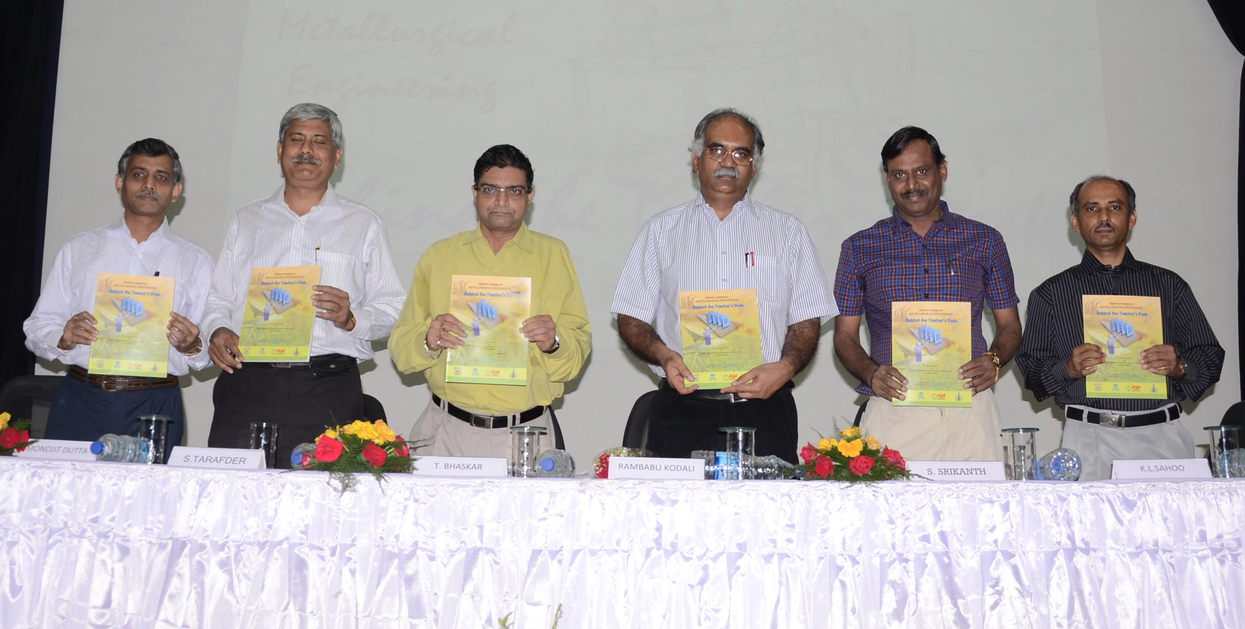
Inaugural Programme of BTTD 2013 organized by IIM Jamshedpur Chapter
The inauguration function of the seminar was held on 5th April, 2013 at CSIR-NML Auditorium and the chief guest of the function was Prof. Rambabu Kodali, Director, National Institute of Technology, Jamshedpur. Dr. S. Srikanth, Director, CSIR-NML in his welcome address cited examples of Indian born Noble Laureates abroad and many other Indian people who have made a mark worldwide with their knowledge and success stories. Dr. Soumitra Tarafder, Head HRG, CSIR-NML and Chairman, BTTD – 2013 highlighted the growing demand of the metallurgy subject and how that can be fulfilled. He said that providing only the subject related education is not enough. The basic concern should be on the quality of education provided, proper research facilities to be made available for the right kind of job performance in near future. Dr. K. L. Sahoo, Principal Scientist, CSIR-NML (convener, BTTD-2013), mentioned that the delegates of BTTD 2013 will get a platform to learn in the open environment, interact with the scientists, engineers and industry professionals and gain through the industrial exposure. Industrial visit to Tata Steel, Usha Martin, Adhunik Steel and CSIR-NML research laboratories was arranged to provide industrial and research exposures to the students.
Professor Rambabu Kodali, Director, NIT –Jamshedpur in his address asked "What is Behind the Teacher's Desk?" He said "There are many things that queue up in one's mind like family, students, society, nation, struggle, pain, stress, nervousness, stories, tales, happiness, free time, memories and so on. But if we sum up everything, the answer to the question would be knowledge, core values, selfless commitment, love and affection to serve student, society and nation, are the elements that are there Behind the Teacher's Desk". He also raised the issue "How to define Education?" According to him education is acquisition of knowledge. It is pertaining to the development of the mind, rather the development of mental power. He encouraged the students by citing examples of famous people like Bill Gates, Steve Jobs, Sakichi Toyoda how hard they worked to get to the position they were in at present.
Guest of Honour to the occasion Dr. T. Bhaskar, Vice President, Metallurgical Services, Usha Martin began his speech with a provoking statement "Innovate or Perish", which is the main motto of today's business in the competitive environment. In a very simple way he explained how one industry differs from the other though both have the access to the same resources. According to him it is the people in the industry who make the difference. Their thoughts, ideas, creativity is what that matters. He said we should look at our local strength and work upon to build that strength from better to best.
On the first day the vote of thanks was proposed by Dr. Manojit Dutta, Secretary, IIM, Jamshedpur Chapter, Head, Coated Products, Tata Steel.
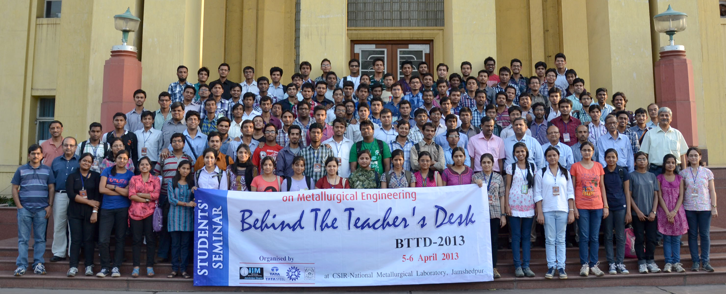
Student delegates and organizing team of BTTD 2013
In the seminar a total of 102 papers were presented in both oral and poster sessions There are 6 technical sessions namely, Raw materials and metal extraction I & II, Advanced materials and failure mechanisms, Metal processing and characterization, Energy, environment and recycling, Mathematical Modeling and Simulation. Visits to industries such as Tata Steel, Usha Martin ad Adhunik Steel and CSIR-NML Laboratory visits were also arranged on the second day of the seminar.
The technical presentations were judged by a team of experts from various organizations on the basis of technical content, presentation skill, etc and best two presenters from each session were awarded prizes. A list of names of the award winners in technical as well as quiz sessions is given below. A grand prize was also awarded to the overall winner among all the presentations and students of IIT-BHU were adjudged as the grand prize winner.

BTTD 2013 Prize winners (Technical Sessions)
Session | Prize | Institute | Winners
Session IA: Raw Materials & Metal Extraction-I | First | IIT – BHU, Varanasi | Ankit, Shubham Sethi, G.S. Mahobia, O.P. Sinha:
Session IA: Raw Materials & Metal Extraction-I | Second | NIT, Jamshedpur | Yasho Vardhan, R.J. Singh, Manis K Jha, S Chandrayan,  Rajesh Prasad
Session 1B: Raw Materials & Metal Extraction-II | First | NIT, Jamshedpur | Minal Shah , Shoumodip Roy
Session 1B: Raw Materials & Metal Extraction-II | Second | GIET, Gunupur | Ch. Sunita, Sudip Kumar Sen, Sangeeta Raut, R.R. Dash
Session IIA: Mathematical Modeling and Simulation | First | NIT- Tiruchirapalli | Mohon Krishna Vinnakota, S. Raman Sankaranarayanan
Session IIA: Mathematical Modeling and Simulation | Second | NIT, Jamshedpur | Ashish Soni, Ritunjay Kumar
Session IIB: Resource, Energy, Environment & Recycling | First | NIFFT-Ranchi | Keerti Pandey
Session IIB: Resource, Energy, Environment & Recycling | Second | O. P. JIT- Raigarh | Anandita Kakwani, Kriti Gautam, Shrijana Pandey, Manjana Choudhary
Session IIIA: Materials Processing and Characterisation | First | Jadavpur University, Kolkata | Ankan Guria
Session IIIA: Materials Processing and Characterisation | Second | Jadavpur University, Kolkata | Syamantak Roy, Rajarshi Sarkar, Shiladitya Sengupta, Tapan Kumar Pal, M Shome
Session IIIB: Advanced Materials and Failure Mechanisms | First | NIT, Jamshedpur | Ravi Kumar Sinha, Abhilash Kumar, Rakesh Kumar Jha
Session IIIB: Advanced Materials and Failure Mechanisms | Second | Jadavpur University, Kolkata | Indrani Biswas, Akashdeep Agarwal, Amritansh Bharech
All | Grand | IIT – BHU, Varanasi | Ankit, Shubham Sethi, G.S. Mahobia, O.P. Sinha

Winners of Poster Session | First | VNIT, Nagpur | Prashant Parshivnikar
Winners of Poster Session | Second | GIET, Gunupur | Rishav Raj, R.R.Dash
Winners of Poster Session | Third | Jadavpur University, Kolkata | S Chakraborty, Anwesha Kanjilal, Ankan Guria
BTTD 2013 Quiz on Metallurgy
A quiz contest on metallurgy was also organized among the participant students. There were seven rounds. The Winner team comprises
First Prize: Ashish Soni (NIT-Jamshedpur), Ravi Kr. Sinha (NIT Jamshedpur) and Ashok K (AcSIR-NML)
Second Prize: M.H Nazir (NIT-Jamshedpur), Gourav Raj (NIT-Jamshedpur) and J R Danda (IIT -BHU)
Third Prize: Ankit (IIT -BHU), Rahul Gupta (IIT -BHU), Minal Shah (NIT Jamshedpur).
The valedictory of the seminar was held in CSIR-NML Auditorium on 6th April 2013. Dr. S. Tarafder, Chairman, IIM Jamshedpur chapter on his opening Speech extended career counselling to the budding metallurgists gathered and expressed his happiness for the successful completion of the event. The participants gave their feedback and expressed their desire to get connected to this productive event. The Chief Guest of the function, Prof. Sankara Raman Sankaranarayanan, HOD from NIT Tiruchirappalli, Tamil Nadu highly appreciated the programme. He added this will encourage the students and develop themselves to the expectation of industries in the years to come. The prizes for the best technical papers and quiz were given by Dr. S. Srikanth, Director, CSIR-NML during the valedictory function. Dr. Srikanth mentioned in his brief address the student should have the hungriness for knowledge and constant drive to update and meet the requirement. This will go long way for career as well to find position in the society. Mr. Nilotpal Dey, Co-convenor, BTTD-2013 and Head, Plant Metallurgical Inspection Group, Scientific Services, Tata Steel proposed the vote of thanks.
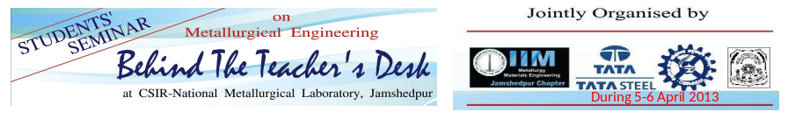
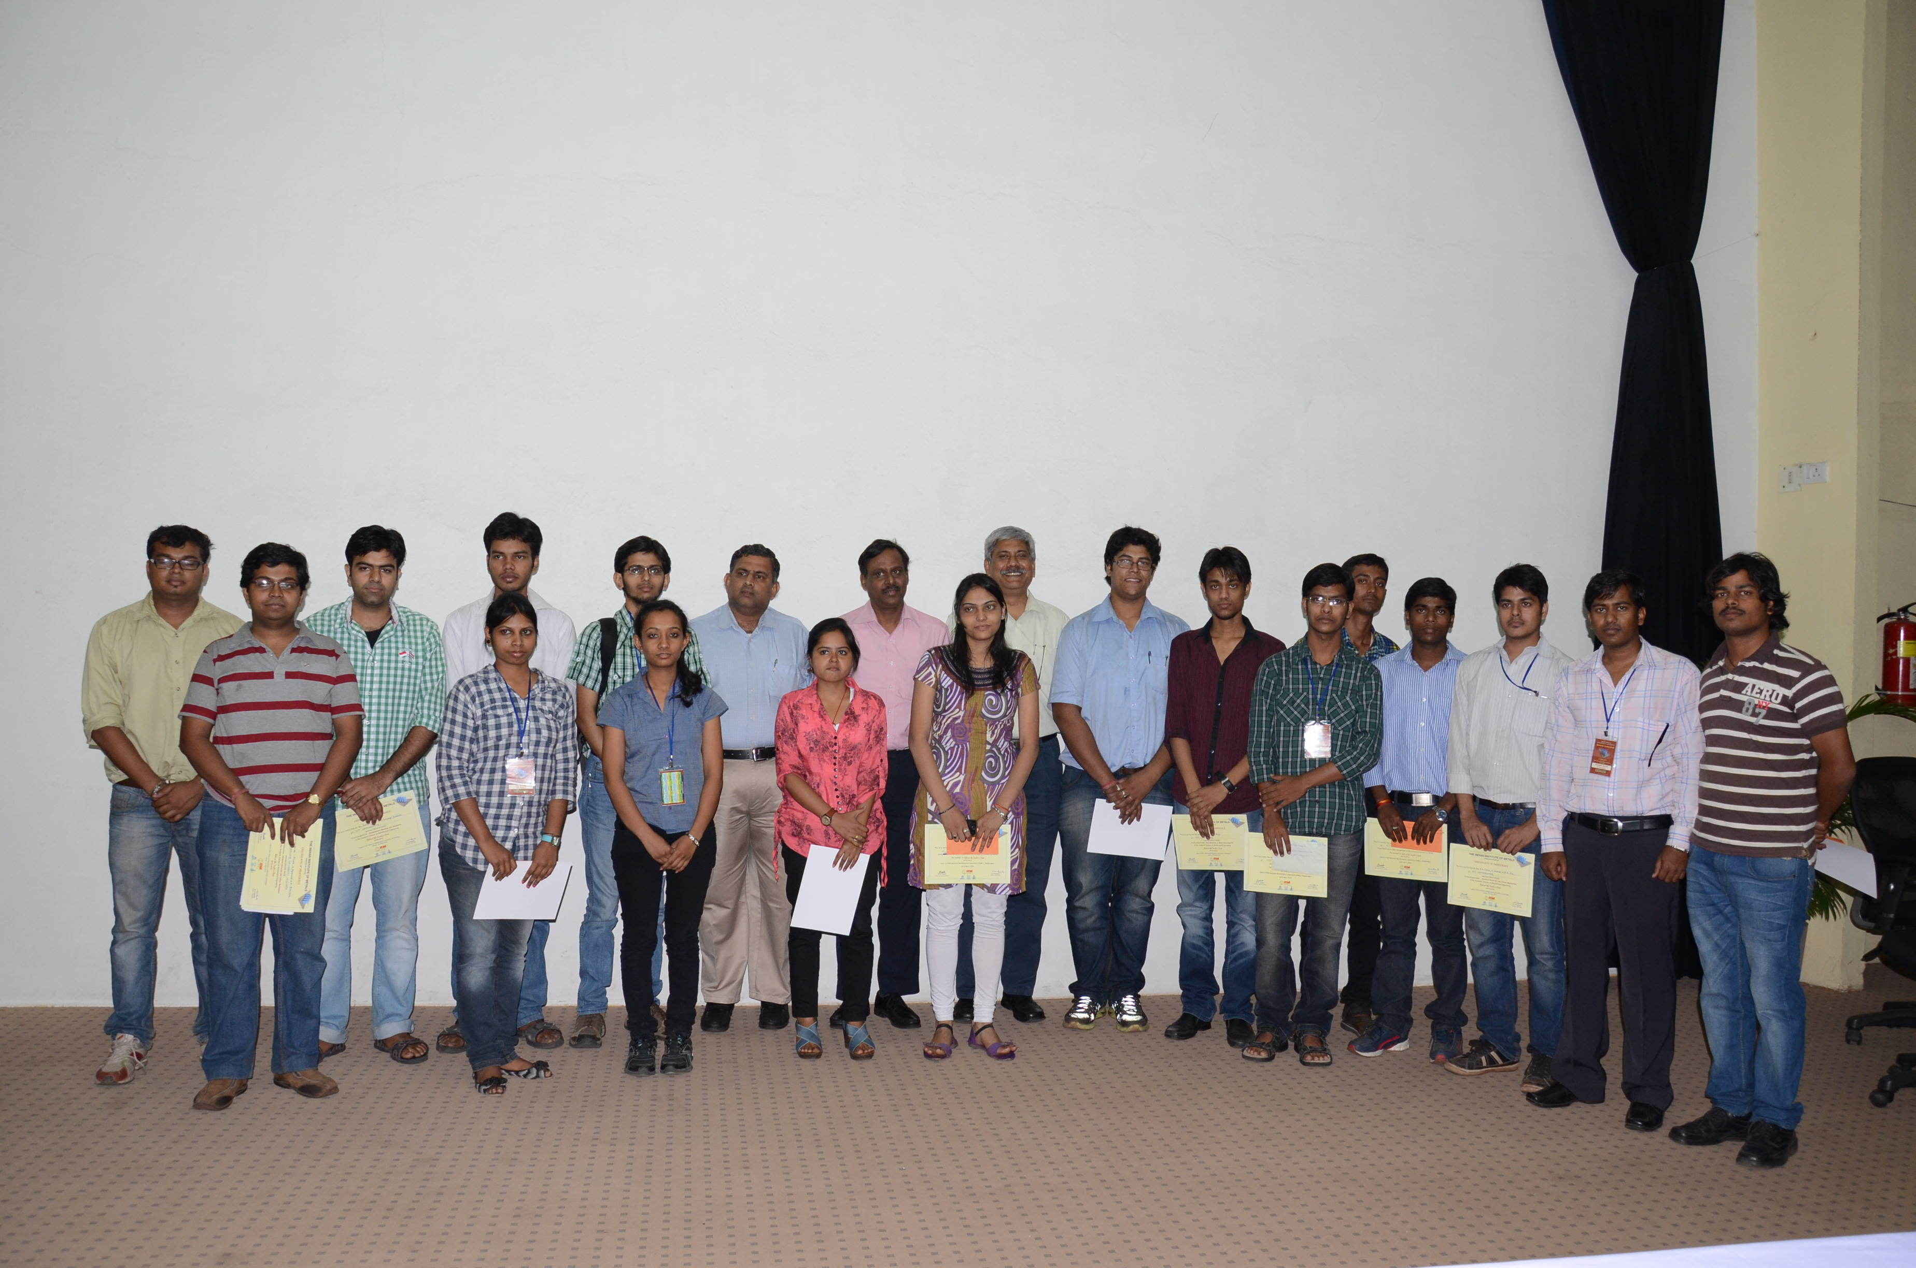
Prize winners of Technical sessions
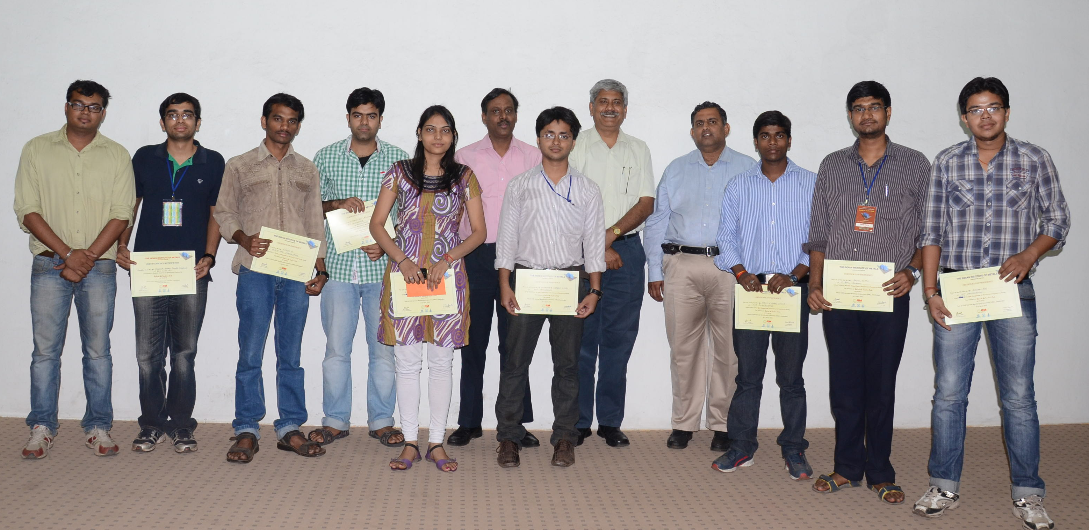
Prize winners of the quiz session

